**Assignment 4**

**Due:** Saturday, 6 August 2022, 11:59 PM

**To do:** Make a submission

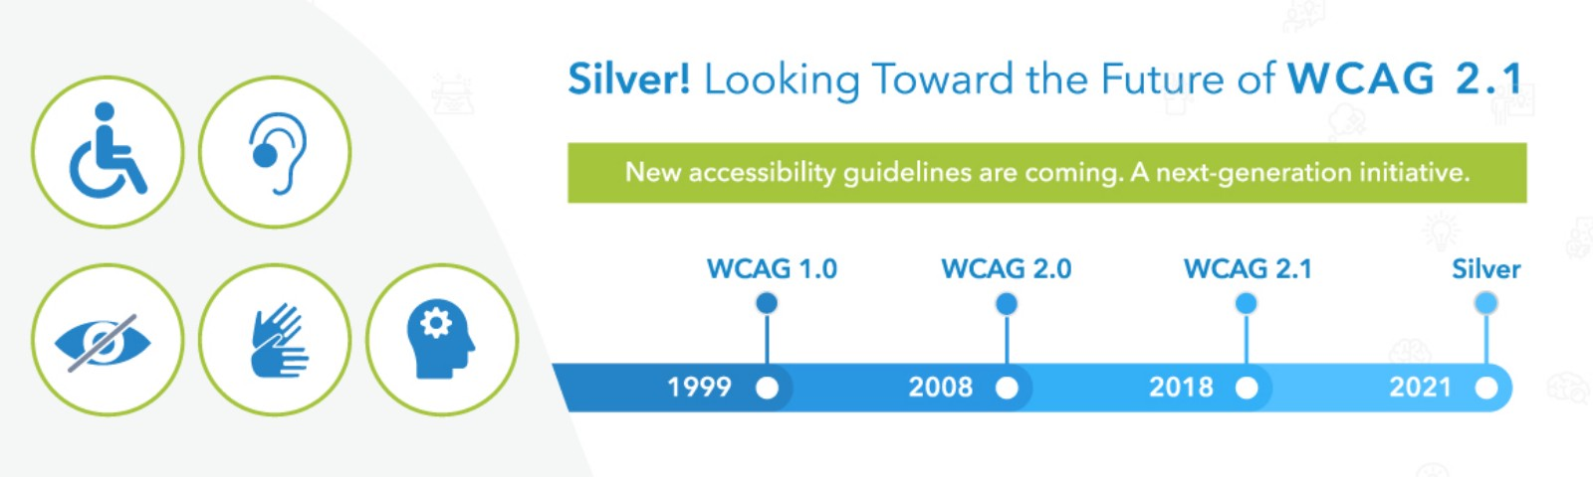

**Web Accessibility**

An accessible website is no longer a nice-to-have, but a must. Lawsuits related to web accessibility are on the rise and you can expect increased regulations as accessibility laws catch up with technology. It's about time that the Canadian companies and businesses need to start fixing their website’s accessibility issues and lower their risk of costly legal issues and damage to thier brand’s reputation.  
  
  
One of the biggest challenges for creating accessible content is to think of all of the different ways people may need to interact with websites. To help people consider what is needed to make sites more accessible, the World Wide Web Consortium (W3C) created the [Web Content Accessibility Guidelines (WCAG)](https://www.w3.org/WAI/standards-guidelines/wcag/) (<https://www.w3.org/WAI/standards-guidelines/wcag/> ). Instead of focusing on highly specific requirements, it is organized in an incremental hierarchical structure, moving from more high-level considerations to more specific ones.  
  
An accessible website is a key to creating a great user experience for all your site’s visitors. The objective of this assignment is to scan a web page for accessibility issues using the [Web Content Accessibility Guidelines (WCAG)](https://www.w3.org/WAI/standards-guidelines/wcag/) (<https://www.w3.org/WAI/standards-guidelines/wcag/> ) international standard recognized by most governments and legislation.

Conducting an Accessibility Scan for a website is a huge and time-consuming activity. For this assignment, we will focus only on a few key principles and elements that will guide your UI design processes to develop and design more accessible interfaces.

The top accessibility principles are:

* **P**erceivable
* **O**perable
* **U**nderstandable
* **R**obust

Visit the Canada Revenue Agency website  - They administer tax laws for the Government of Canada and for most provinces and territories -  at <https://www.canada.ca/en/revenue-agency.html> (<https://www.canada.ca/en/revenue-agency.html> )and identify accessibility issues and shortcomings on the **MAIN PAGE**  only. Where does the website main page fall short or fail from an accessibility standpoint?   
  
Check for the following (wherever applicable):  
  
**1. Perceivable:**The perceivable principle covers considerations that are important for users who may perceive your content differently. Check for:

* + Non-Text Content (see if illustrations, image links, icons, and charts are available)
  + Descriptive Text (links and buttons contain descriptive text and not generic phrases such as "click here", "here", "more", "more information", "read more", "continue," etc.
  + Time-based media (audio, visual, or audiovisual content availability)
  + Adaptable Content (headings are clear, bigger, and bolder than the paragraph text)

**2. Operable:**Operability is about supporting users that need alternative input. Check for:

* + Keyboard Accessible (Interactive element on the site should be operable with a keyboard, e.g navigate in menu items with arrow keys or tab)
  + Enough Time (Gives enough time, for example, If the page can time out, whether it’s an interactive form or a login, a warning is given before the page expires and gives a chance to extend the session.)

**3. Understandable**: Understandability is a matter of usability. This principle helps users understand the content and how the site and its elements behave. Check for:

* + Readability (content is readable - font choice and size)
  + Predictability (Predictability is all about consistency! Are repeating elements consistent, e.g. like navigation from page to page)

**4. Robust**: Content must be robust enough that it can be interpreted reliably by a wide variety of user agents, including assistive technologies. Check for:

* + Responsiveness (render well on a variety of devices or screen sizes from minimum to maximum display size)
  + Cross-browser compatibility (does not change its content, meaning, or delivery when accessed at different browsers: Chrome, Firefox, Internet Explorer, etc.)
  + Alternatives (some alternatives are provided, for example, options to report an error, etc.)

**Deliverable**No set deliverable style, it is up to you how you present your findings; it could be a report (max one page), demo video (max 3 min), or a poster representing text, charts, lists, data, visuals, or graphs - be creative!

**Evaluation Criteria and Rubric:**

|  |  |  |  |  |
| --- | --- | --- | --- | --- |
| **Exceeding** | **Meeting** | **Approaching** | **Beginning** | **Needs Improvement** |
| **5** | **4** | **3** | **2** | **1** |
| Creative and sophisticated presentation of the issue, reflecting a clear understanding of nuances and context. Thorough demonstration of reasons and evidence to support one's position using session material and research. | Clear presentation of the issue, reflecting an understanding of nuances and context. Demonstration of reasons and evidence to support one's position using session material and research. | Presentation of the issue, reflecting an understanding of nuances and context. Some demonstration of reasons and evidence to support one's position using session material and research. | Minimal reflection of the understanding of nuances and context. No demonstration of reasons and evidence to support one's position using session material and research. | Absence of reflection of the understanding of nuances and context. No demonstration of reasons and evidence to support one's position using session material and research |

### Submission status

|  |  |
| --- | --- |
| **Submission status** | No attempt |
| **Grading status** | Not graded |
| **Time remaining** | 8 days 10 hours |
| **Last modified** | - |
| **Submission comments** | [Comments (0)](https://eclass.srv.ualberta.ca/mod/assign/view.php?id=6138532) |